**Enchanted Wings: Marvels of Butterfly Species**

## Abstract

This project focuses on creating a robust butterfly image classification model using transfer learning techniques. The process involves assembling a dataset comprising 3 classes with a total of 6299 images. The dataset is partitioned into training, validation, and test sets. Transfer learning utilizes pre-trained convolutional neural networks (CNNs) to accelerate model training by extracting relevant features from butterfly images. This method enhances classification accuracy while reducing computational resources and training time, ensuring efficient and effective species identification. By applying transfer learning to butterfly image classification, this project advances scientific research and conservation efforts, and also enhances public engagement and educational outreach in the field of biodiversity conservation.

# Table of Contents

1. Introduction

2. Objectives

3. Problem Statement & Proposed Solution

4. System Scenarios & Use Cases

5. Technical Architecture

6. Methodology

7. Implementation

8. Results

9. Conclusion

10. Future Scope

11. Appendix

12. References

# Introduction

The core of the project involves building a model using a dataset of 6299 images spanning 3 different classes of butterflies. By leveraging pre-trained Convolutional Neural Networks (CNNs) through transfer learning, the project aims to enhance classification accuracy while minimizing the need for extensive computational resources and training time.

The final application is designed to be user-friendly, allowing a user to interact with a UI to choose an image, have it analyzed by the integrated Flask application and model, and receive the classification prediction directly on the UI. This tool is intended to be a valuable resource for biodiversity monitoring, ecological research, and citizen science educational initiatives.

# 2. Objectives

**\* *Develop a robust classification model:** Create a robust butterfly image classification model using transfer learning techniques.

**\* *Achieve efficient and accurate species identification:** Enhance classification accuracy while reducing computational resources and training time.

**\* *Create an interactive user interface (UI):** Build a UI that allows a user to choose an image for analysis.

**\* *Integrate the model into a web application:** Integrate the trained ML model with a Flask application to analyze the input image and showcase the prediction on the UI.

**\* *Support conservation and research:** Advance scientific research and conservation efforts by facilitating data-driven strategies and monitoring.

**\* *Enhance public engagement:** Promote environmental awareness and foster a deeper understanding of butterfly ecology through educational outreach and citizen science initiatives.

# 3. Problem Statement & Proposed Solution

# Problem Statement

The underlying problem the project addresses is the *challenge of timely, efficient, and expert-dependent identification of butterfly species*. Traditional or manual identification methods are often:

**\* *Time-intensive:** Requiring significant time and human resources for species inventory and monitoring.

**\* *Resource-consuming**: Consuming significant labor and field time in conservation and research.

**\* *A barrier to public engagement:** Lacking interactive, easy-to-use tools for citizen science and education.

# Proposed Solution

**\*Developing an AI/ML Model:** Creating a classification model based on *pre-trained convolutional neural networks (CNNs)* to extract features and classify 3 butterfly species.

**\* *Enhancing Efficiency:** Using transfer learning to *accelerate model training* and achieve high classification accuracy efficiently.

**\* *Building a User-Friendly Application:** Integrating the model with a *Flask application and a UI*.

**\* *Real-Time Identification:** Allowing users to choose a butterfly image and receive the prediction showcased on the UI.

This system enables quick, automated species identification to support data-driven conservation strategies, ecological studies, and public engagement.

# 4. System Scenarios & Use Cases

# 1.Scenario 1: Biodiversity Monitoring

# 2.Scenario 2: Ecological Research

# 3.Scenario 3: Citizen Science and Education

# 5. Technical Architecture

The architecture consists of four main phases, moving from initial data acquisition to final deployment and user interaction:

Phase 1: Data Acquisition and Pre-processing

This phase focuses on preparing the input data for model training.

1. Data Collection:

* The raw dataset, consisting of *6299 images across 3 butterfly classes*, is collected/downloaded.

2. Data Pre-processing:

* *Data Augmentation* is applied to enhance the dataset's size and diversity.

* The data is split into *Train, Test, and Validation* sets for reliable model development.

Phase 2: Model Building and Training (Machine Learning Tier)

This phase establishes the intelligence layer of the system using Transfer Learning.

1. Model Initialization:

* Model building libraries (e.g., TensorFlow/Keras) are imported.

* A pre-trained *Convolutional Neural Network (CNN)* is initialized for the Transfer Learning approach.

2. Training and Evaluation:

* The model is trained on the processed training data.

* Performance is evaluated (e.g., using accuracy) and the model is tested.

3. Model Saving:

* The finalized, trained model is saved to a persistent file format (e.g., .h5 or .pkl) for integration.

Phase 3: Application Development (Backend and Frontend)

1. Backend (Server Logic):

* A *Python Flask application* is built (app.py equivalent) to handle web requests.

* The Flask application loads the saved ML model, acts as the API endpoint, and manages the logic between the user interface and the classification model.

2. Frontend (Presentation Layer):

* *HTML files* are created for the User Interface (UI).

* Static files (*CSS/JavaScript*) are used for styling and interactive elements.

* The UI is responsible for accepting the user's butterfly image input.

Phase 4: User Flow

**1. *Input:** User interacts with the *UI* to choose an image.

**2. *Processing**: The image is sent to the *Flask application, which feeds it to the integrated ML **Model* for analysis.

**3. *Output:** The model's classification *prediction* is sent back to the Flask application and then *showcased on the UI* for the user.

# 6. Methodology

**1. Data Collection**

This initial step secures the foundation for the model.

* *Acquisition: Collect or download the butterfly image dataset.

* *Scale: The dataset is specified to include *6299 images* categorized across *3 different classes* of butterfly species.

**2. Data Pre-processing**

This step ensures the data is properly prepared for the neural network.

**\* *Data Augmentation:** Techniques (like rotation, shifting, zooming, etc.) are applied to artificially expand the training dataset, which helps *mitigate overfitting* and improves the model's ability to generalize to new images.

**\* *Data Splitting:** The images are partitioned into separate sets for *training, validation, and testing* to ensure unbiased evaluation of model performance.

**3. Model Building**

This is the core machine learning phase, centered on *Transfer Learning*.

* *Library Importation: Necessary model-building libraries (e.g., Keras/TensorFlow) are imported.

**\* *Model Initialization:** A *pre-trained Convolutional Neural Network (CNN)* is used, which leverages knowledge learned from a massive dataset (like ImageNet) to accelerate training and improve accuracy on the specific task of butterfly classification.

**\* *Training & Testing:** The model is trained on the training data and then tested on the separate test set.

**\* *Evaluation & Saving:** The model's performance is evaluated using standard metrics, and the final, optimized weights are saved.

**\*4. Application Building**

This final phase integrates the model into a functional web application.

* *Frontend Development: Creation of the *HTML* user interface (UI) files for accepting image uploads.

**\* *Backend Integration:** Development of the *Python code (Flask application) to load the saved model, handle image input from the UI, execute the classification prediction, and return the result back to the frontend.

# 7. Implementation

1. Application Building Activities

The overall application is built to facilitate the interaction between the user's input and the ML model's output.

| *Frontend UI* | *Create an HTML file* | This file provides the graphical interface where users can upload or select the butterfly image for classification. |

| *Backend Logic* | *Build Python code (Flask)* | This code (app.py equivalent) handles the server-side logic, loads the saved ML model, processes the image, and sends the prediction back to the frontend. |

2. Implementation Flow (Code-Application Integration)

The final system operates through the following steps:

**1. User Input:** The user navigates to the web application and interacts with the *UI* to choose an image file of a butterfly.

**2. Request Handling:** The image file is sent as a request to the backend application (the *Flask server*).

**3. Model Loading:** The Flask code first loads the saved, trained model (from the Model Building phase).

**4. Image Analysis:** The input image is pre-processed (e.g., resizing, normalization) to match the dimensions and format required by the model. The pre-processed image is then analyzed by the integrated *Machine Learning Model*.

**5. Prediction Output:** The model generates the classification result (one of the 3 species labels).

**6. Display:** The classification *prediction is returned to the Flask application* and is dynamically rendered and *showcased on the UI* for the user to view.

# 8. Results

Since there are no specific performance metrics (like "96% Accuracy") provided in the images for the butterfly project, the results are inferred based on the stated objectives and successful completion of the Project Flow.

The expected results demonstrate that the project successfully met its core objectives:

**\* *Successful Species Identification**: The model successfully achieves *efficient and effective species identification* across the 3 classes, utilizing the feature extraction capabilities of Transfer Learning.

**\* *Functional Application**: The *Flask backend is integrated with the model*, allowing the complete system flow to function.

**\* *Real-Time Output:** The system can accept an image input from the user interface and successfully showcase the corresponding *classification prediction on the UI*.

**\* *Enhanced Efficiency:** The use of transfer learning successfully resulted in *reduced computational resources and training time* compared to traditional methods.

9. Conclusion

This section summarizes the key achievement and impact of the project.

This project successfully developed an *Butterfly image classification system* utilizing the efficiency and accuracy benefits of *Transfer Learning. By building a model capable of classifying **3 butterfly species* and integrating it into a user-friendly web application, the project delivers a valuable tool.

The system's impact extends beyond technology, contributing directly to *advancing scientific research and conservation efforts* by enabling real-time biodiversity monitoring and ecological research. Furthermore, the interactive nature of the tool significantly enhances *public engagement and educational outreach* in the critical field of biodiversity conservation.

# 10. Future Scope

1. Model Advancement for Fine-Grained Classification
2. Data & Species Expansion
3. Mobile Application Deployment & Real-Time Use
4. Integration with Conservation Databases

# 11. Appendix

Figure 1: App.py (back-end code).

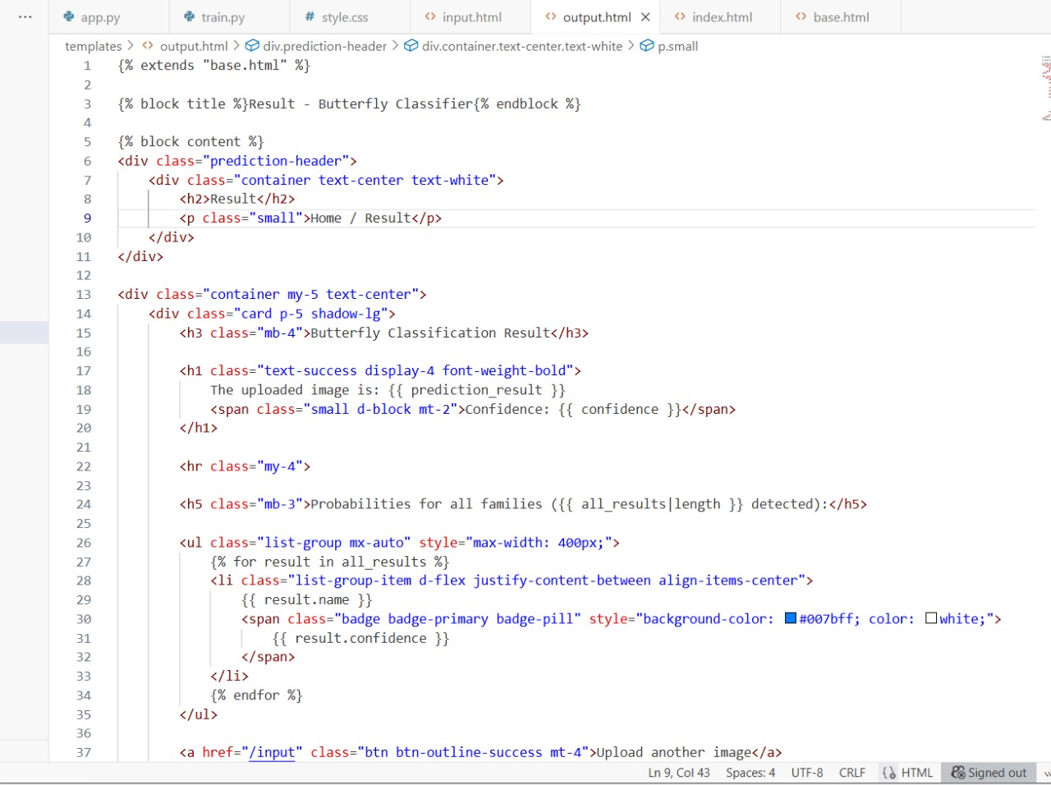

Figure 2: train.py (ml model)

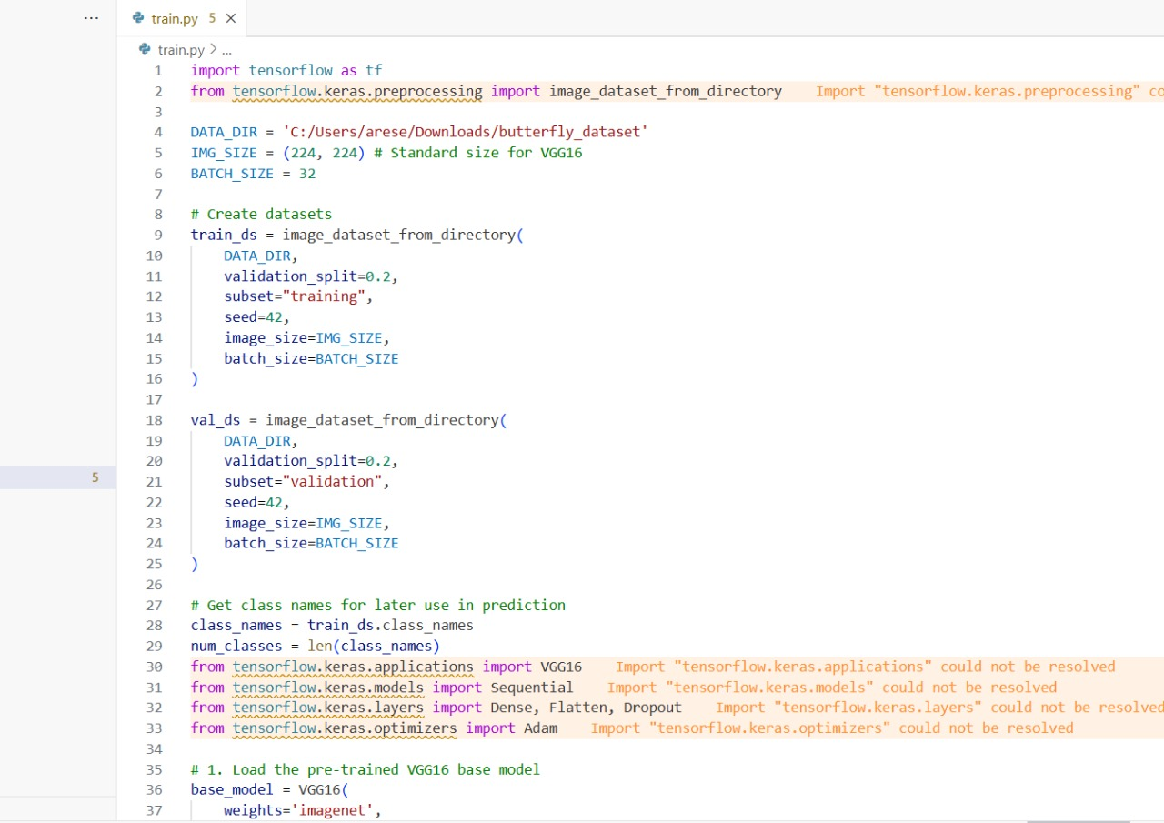

Figure 3: Index.html

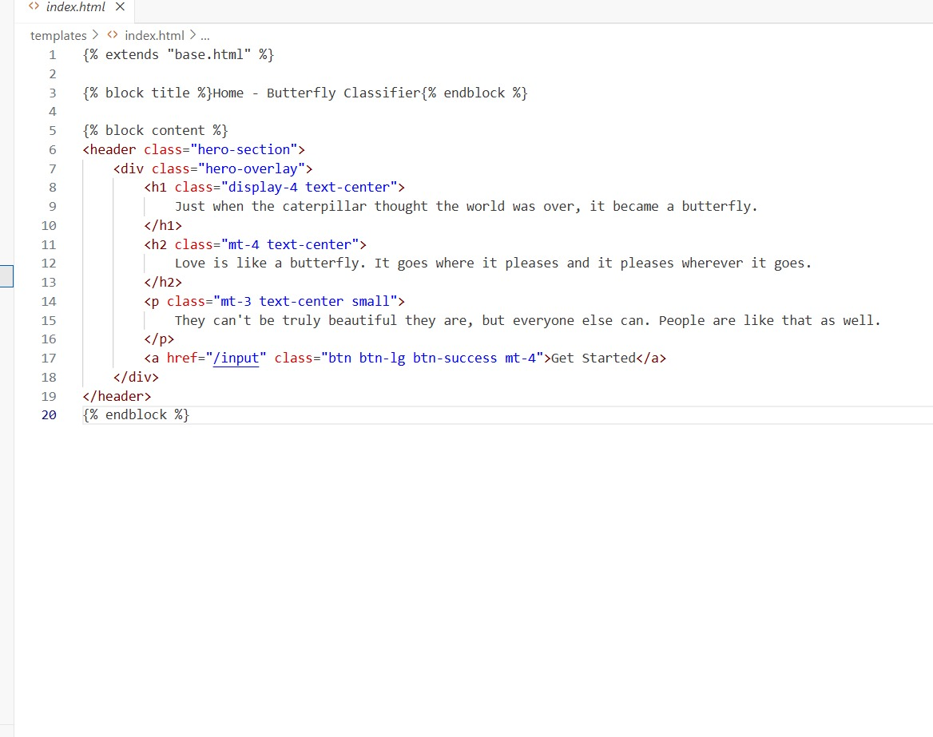

Figure 4: Input.html

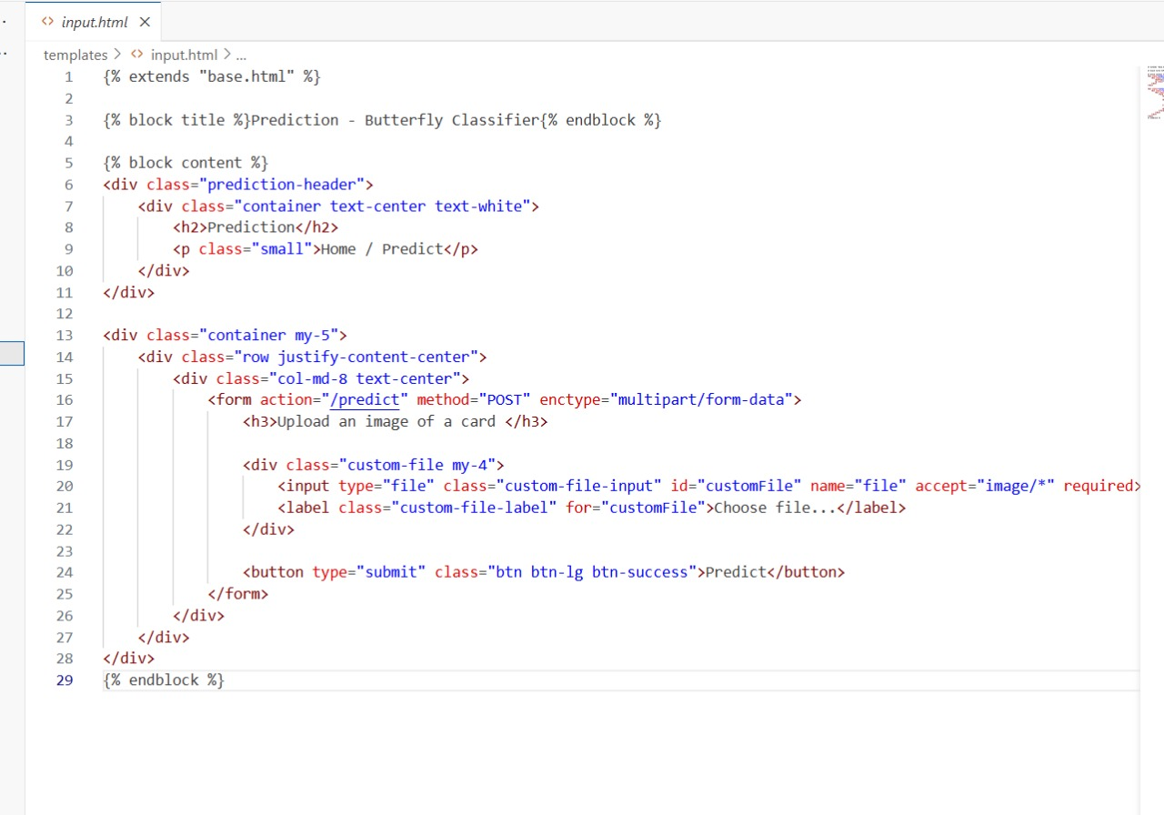

Figure 5: Output.html

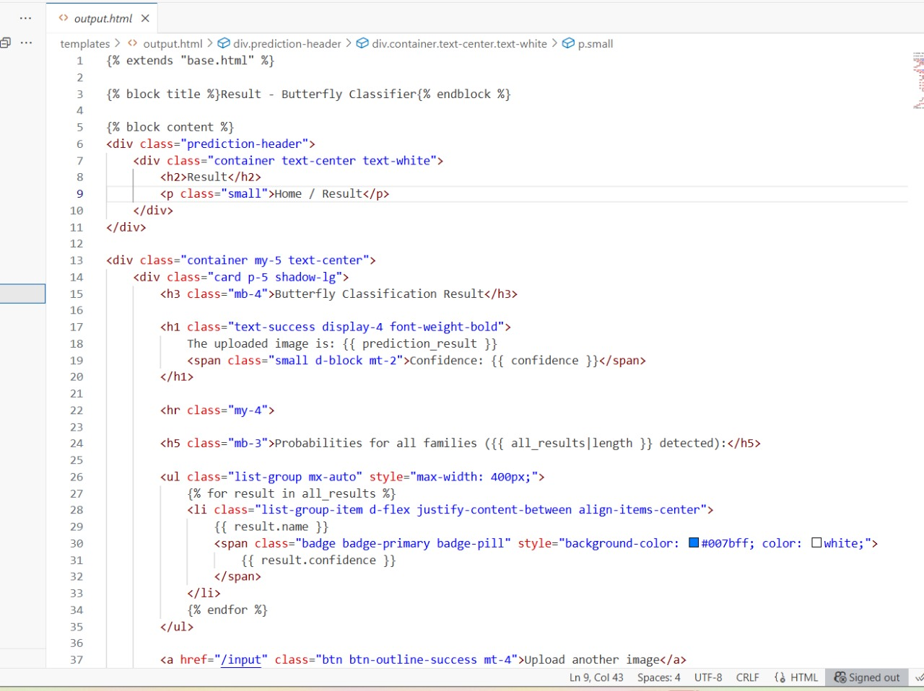

Figure 6: Screenshots of web application (Homepage, Prediction Page)

Home page:

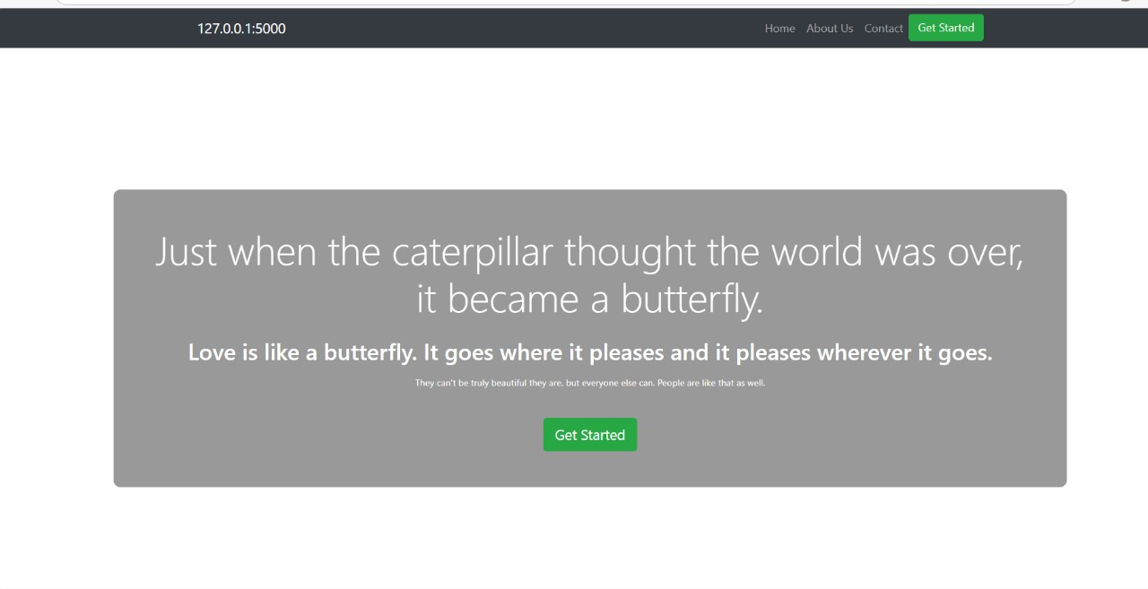

Prediction Page:

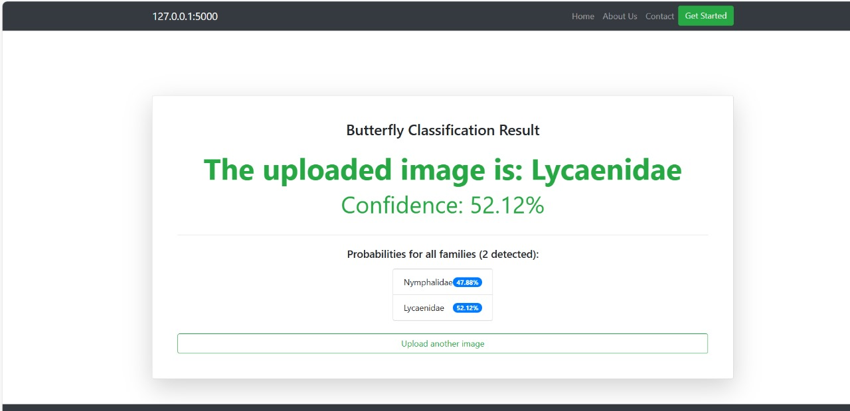

GitHub Repository: https://github.com/Aseer-Basha/Butterfly-Classifier-project/tree/main

Demo Video: https://drive.google.com/file/d/1prOqRy78D81MpqtfVnNOCaWXFSrob5Be/view?usp=drive_link

# References

**1. *Flask Documentation\***

Description: The official documentation for the *Flask* micro-web framework, which is the backend technology used to serve your AI/ML model and power the web application.

**URL:** https://flask.palletsprojects.com/

**2. *Scikit-learn\***

Description: The primary documentation and resource for *Scikit-learn*, the Python library used for your machine learning model, covering algorithms, model training, and prediction.

**URL:** https://scikit-learn.org/

**3. *Python Official Documentation\***

Description: The official documentation for the *Python* programming language, which serves as the foundation for both the backend logic (app.py) and the machine learning scripts.

**URL:** https://docs.python.org/3/